Task 1: Create a Digital Literacy Awareness Infographic

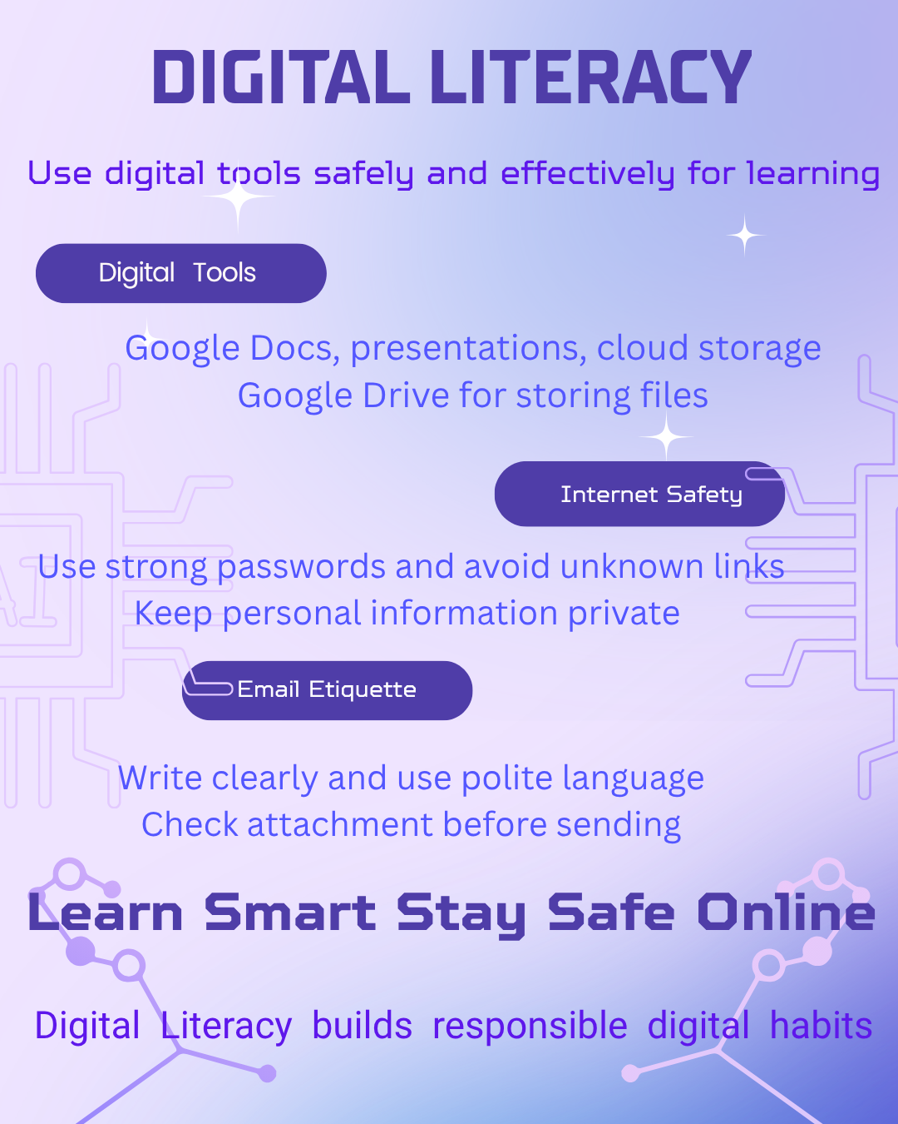
For Task 1, I used Canva to create a digital literacy infographic. Canva was selected because it provides simple templates, design elements, and editing tools that help in creating attractive educational visuals easily. My infographic is titled “Digital Literacy” and focuses on important areas that students need in digital learning.
The design includes three main topics: digital tools, internet safety, and email etiquette. Under digital tools, I mentioned useful student tools such as Google Docs, presentations, and Google Drive for storing files.
In internet safety, I explained the importance of strong passwords, avoiding unknown links, and protecting personal information. Under email etiquette, I included writing clearly, using polite language, and checking attachments before sending emails.
One interesting part while creating the infographic was arranging information in a simple visual format without making the page crowded. A small difficulty was fitting all the content neatly into the template while keeping the design readable and balanced.

